WHAT IS NATUROPATHY DIET?
Naturopathy diet menu has been followed as a legacy since ages. Nature is considered as the greatest healer mending every broken bond and taking care of each individual like a guardian. A drugless system of pure healing constituting in the art and science of healthy living is what Naturopathy diet chart is known for.
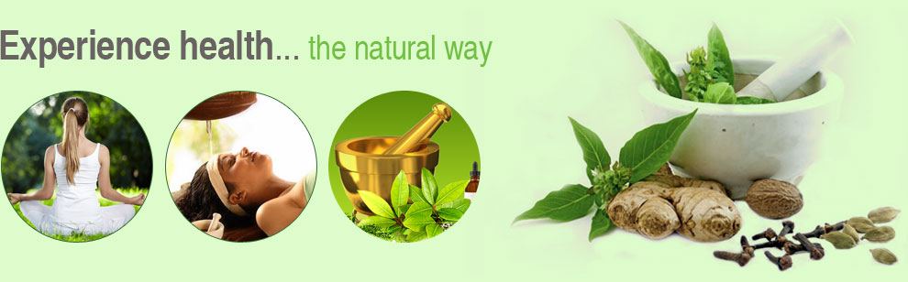
Is completely giving up benefiting anyway?
There are hundreds of techniques available in the market, but none promises to keep the health well-maintained and fit. No more worries! Naturopathy diet meal plan is a one-way solution to cure all health-related issues and there must be something extraordinary about it that it has find place in ancient writings (Vedas). Let’s have a look.
Naturopathy recipes work on principles of nature itself be it physical, spiritual or moral dimensions of living. Saints followed the same routine and history has witnessed their long healthy lives. Not to exaggerate more, let’s answer some questions: what is Naturopathy diet plan and how to introduce Naturopathy food in our daily schedule?
What to eat in a Naturopathy diet menu?
Naturopathy diet meal plan includes intake of organic fruits and vegetables (seasonal), whole grains (organic), proteins- meat, beans etc. The main motive of naturopathy diet plan is to inculcate a healthy flow of vitals so that they perform their level best and provides us a super healthy life.
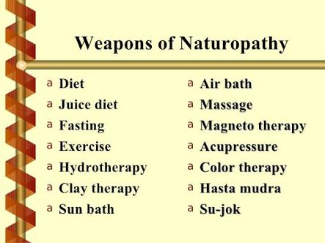
What is Naturopathy diet chart and what steps to follow:
• Identify the problem causing area.
• Work on the cause and make a Naturopathy diet meal plan accordingly.
• Select Naturopathy food which suits and fulfills the requirements.
What is Naturopathy diet and weight loss?
The first thing a person looks up in diet is how to reduce weight through it. Naturopathy diet and weight loss techniques are thereby presenting an amazing show to this. Every may help you loose some water weight but they never guarantee a permanent solution to weight loss. The quickly reduced weight is gained even more quickly after leaving the diet plans. Naturopathy diet plan guarantees to remove the weight permanently and cure some diseases that take a disadvantageous form later on. How? Through a natural take-care process!
Naturopathy diet menu promotes use of whole fruits and grains (minimum processing done) in their perfectly natural state. And farm products with no preservatives added and free from chemical artificial ingredients mixed.
The above introduction of food items in the Naturopathy recipes make it shine among rest of the diet plans. It is said to work as a remedy for people facing food toxicity, issues in liver or kidney, physical imbalances, thyroid disease and keeps us away from alcohol addictions too! Once implemented properly, it ensures a hopeful hand not leaving you alone and to provide energy.
Thus, Naturopathy diet and weight loss goes hand in hand eliminating the cause of illness and introducing a fresh start to the body.
Good Naturopathy diet recipes exclude fried items, bed tea, carbonated beverages and intake of large amount of caffeine regularly. Although, small quantities may be taken once a month to keep going with the Natural personality.
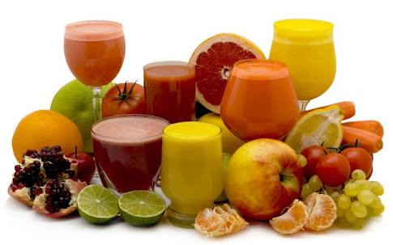

How can Naturopathy diet chart benefit in skin related problems?
The morbid matter that keeps on adding in the body in form of junk food or overeating habits are best to remove as soon as possible. Once they start making spaces for themselves, outer skin also comes under its control. The body cells get blocked when not aerated sufficiently and leads to dead skin cells which deform the skin and eventually looks are compromised. Naturopathy recipes are waiting to be inculcated in routines to give your skin a perfect care.
I've seen ladies approaching to beauty parlors for a make over rather than changing food habits! This is what needs to be done- A naturopathy diet meal plan to follow.
A healthier stomach leads to a happier day!
We always try to preach others to how they can change their habits while we lack in making ours good. This is the high time you think about yourself and give Naturopathy food a chance to turn your life upside down- from hell to heaven!

